# Ulysses Palomar - Firewall

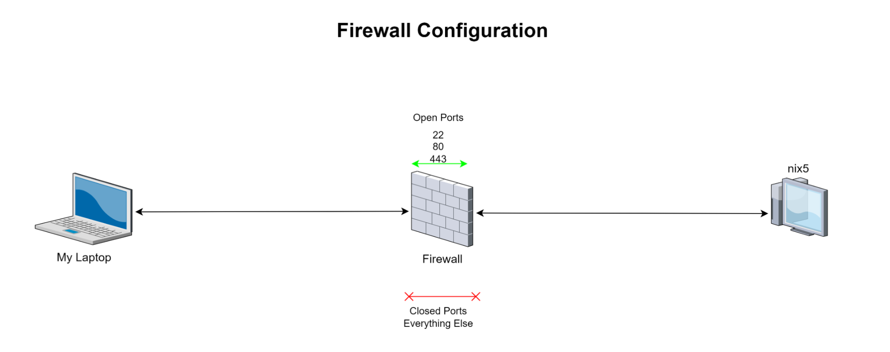

# Mike Stog - Load Balancing / NFS

**Load Balancer**

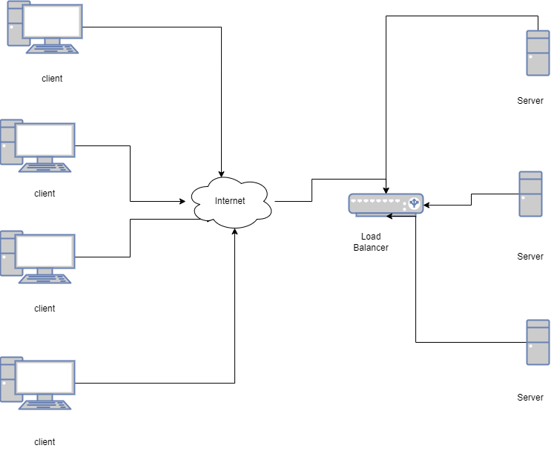

**Network File System (NFS)**

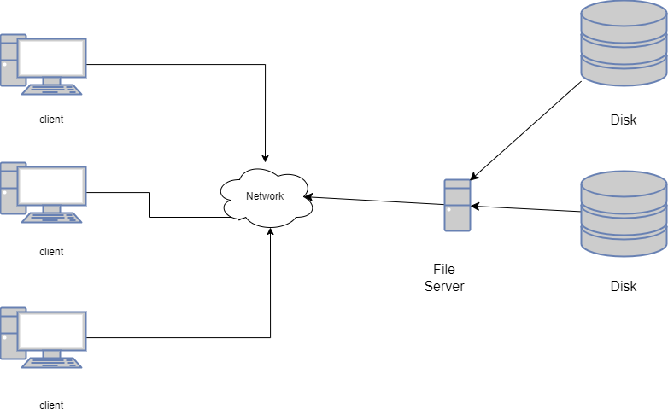

Caleb Fager - Zabbix Monitoring Service

